# EggsOrder.java Test Table

|  |  |  |  |
| --- | --- | --- | --- |
| **Input** | **Expected Output** | **Actual Output** | **Comment** |
| 26 | $16 | $16 | Refer to Screenshot 1 |
| 13 | $8 | $8 | Refer to Screenshot 2 |
| 57 | $35.75 | $35.75 | Refer to Screenshot 3 |
| 129 | $79.25 | $79.25 | Refer to Screenshot 4 |

# Screenshot 1

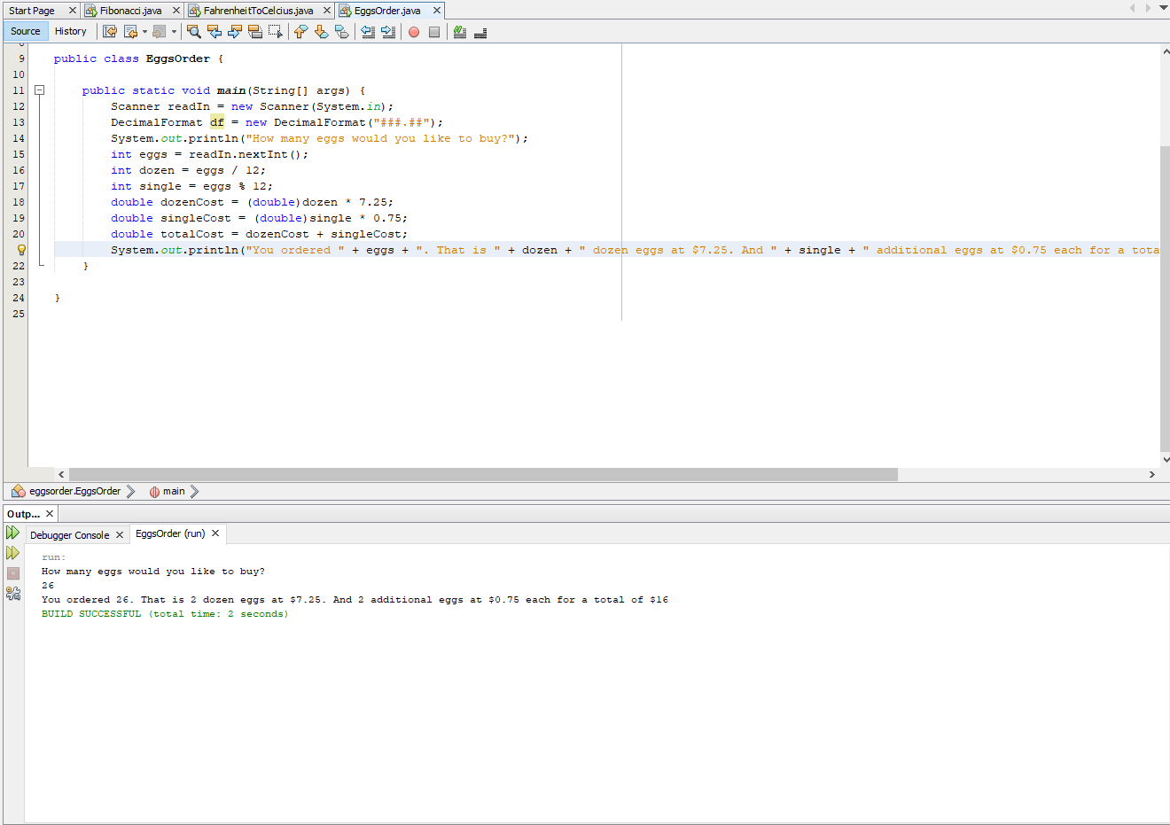

# Screenshot 2

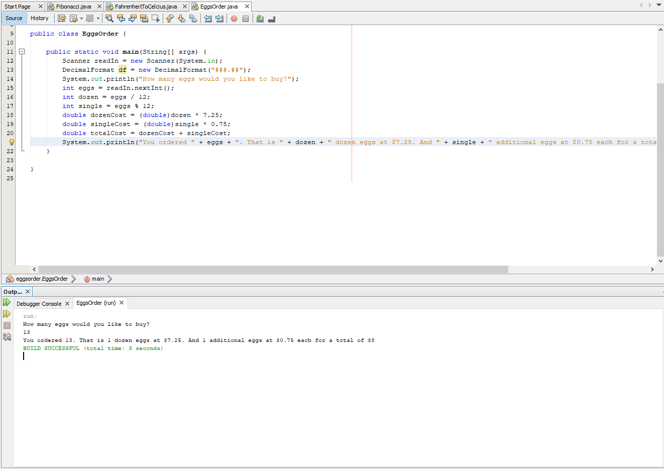

# Screenshot 3

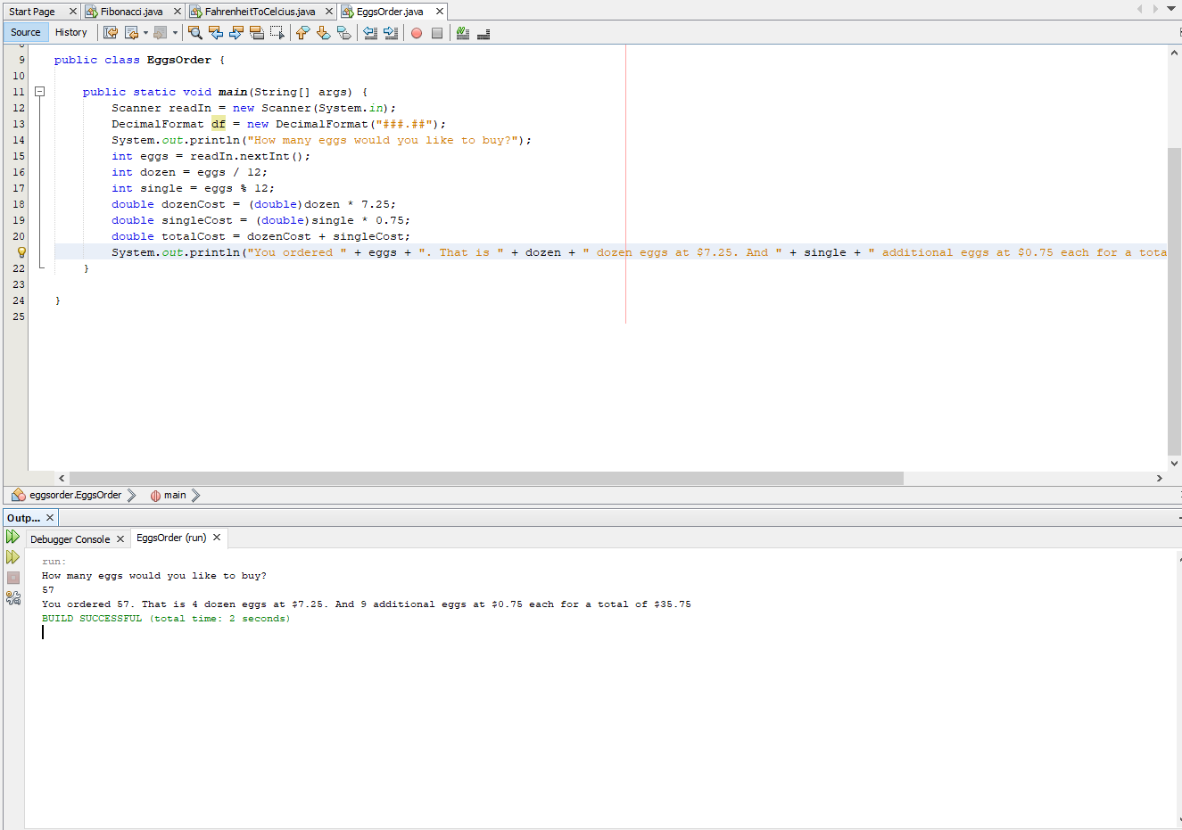

# Screenshot 4

